**LIST OF ABBREVATIONS**

|  |  |
| --- | --- |
| **Abbreviation** | **Illustration** |
|  |  |
| VPN | Virtual Private Network |
| IP | Internet Protocol |
| IDS | Intrusion Detection System |
| TCP  GSM  GPS  RT  PDU  DDOS | Transmission Control Protocol   Global System for Mobile Communications  Global Positioning system  Real Time  Pre-Defined User  Distributed Denial of Service |
|  |  |

**LIST OF FIGURES**

|  |  |  |
| --- | --- | --- |
| **Figure** | **Illustration** | **Page No.** |
|  |  |  |
| 3.1 | GPS Board |  |
| 3.2 | SIM 800L GSM |  |
| 4.1 | System Architecture |  |
| 4.2 | System overview |  |
| 4.3  4.4  4.5  4.6  4.7  4.8  4.9  4.10  5.1  5.2  8.1  8.2  8.3  8.4  8.5  8.6  8.7 | DFD Level - 0  DFD Level- 1  Class Diagram  Circuit Diagram  Deployment Diagram  Use Case Diagram  Sequence Diagram  State Machine Diagram  Project Breakdown Structure  Team Structure  Red light view  Yellow light view  Emergency Blynk 1  Emergency Blynk 2  Emergency Blynk 3  Location View on Phone  Green light view |  |
|  |  |  |
|  |  |  |
|  |  |  |
|  |  |  |
|  |  |  |

**LIST OF TABLES**

|  |  |  |  |  |
| --- | --- | --- | --- | --- |
| **Table** | **Illustration** | | **Page No.** | |
|  | |  | |
| 3.1 | Arduino Nano Specifications | |  | |
| 5.1  5.2  5.3  7.1 | Cost Estimation  Risk Management  Schedule Plan  Test Cases | |  | |
|  |  | |  | |
|  |  | |  | |

**CHAPTER 1**

**INTRODUCTION**

* 1. **Overview**

Existing handheld devices that are available for women safety require women intervention to activate them such as pressing the button or shake the device etc. after sensing the danger. However, for some reason if a woman has no time to activate it when she is danger, then the purpose of the safety device is not solved. In a country like India where the growth rate of crime is considered to be more than the growth rate of population, which includes burglary, murders, rapes, and many more women’s safety is believed to be one of the most important issues. According to a report by Thomson Reuters Foundation, India is ranked as a highly dangerous place for women worldwide, India has the greatest number of child brides as well. In 2016, the number of reported rapes is almost 39,000. Experts that were interviewed for the reason why India is presumed to be dangerous for women said India is on top of the list because its government has done almost nothing to provide safety to women since the rape and murder of a student in early 20’s in 2012 which prompted changes in the rape laws of the country. Most of the attacks on women happen when they are traveling alone or are in a remote area where they are not able to find any help or proper assistance. This paper proposes a IoT based solution to address the problem of women safety and that overcome the shortcomings of existing devices. The proposed design comprises of features to notify family members and nearby police station for immediate assistance when women are not safe. Moreover, a shock wave generator is a part of the proposed design which women can use to attack the perpetrator

* 1. **Motivation**

As an engineering student a project is required as part of the final year work. The project

Chosen is safety detector system at public places. Women in our country are unsafe everywhere. Public place safety is the need of the hour because the cases of harassment are increasing day by day. There are many reasons why women chose to keep silent when they come across any sort of harassment. The main motto behind initiating this application is to empower women and encourage them to claim their rights when injustice takes place. This application will help them express their views and make it go viral to ensure create a safe environment for others

* 1. **Problem Definition And Objective**

Technology has advanced so much in the last decade or two that it has made life more efficient and comfortable. In today’s time CCTV cameras are everywhere but not sure how many of them are functional and at which extent it has been useful to deter the crime. Incidences do take place in spite of police patrolling. Majority of the women hesitate to approach police station directly to speak about the discomfort/pain when something happens to them either publicly or privately. Objective of this project is to encourage women to become their own ‘Sheroes’ in order to ensure their safety at public places and To Help women to send emergency messages and location in case of she feels unsafe.

* 1. **Project Scope And Limitations**

Through this safety mechanism, women will be capacitated to raise their voice & express themselves on the issue of safety. Women will be able travel in a safe and conducive environment. This system will also help them to become confident/alert about their safety which will lead to Public places become safer. Storing and training the data using Machine Learning Algorithm can give notification even before she enters area We may add a feature of emergency helpline numbers such as nearby police stations, Women help groups, nearby NGOs etc. This app can be customized and used at a workplace to address the workplace harassment. We can also link police dept through this app and the notification can be sent through this app to nearby on duty police and they can be at the crime scene within minutes.  The translation of the content can be done in Local languages.  An offline survey can be conducted with the help of this application and testimonials of real live witnesses can be added for others to refer as a strong evidence.

As it’s a experimental project, low quality GPS module is used which makes it hard to get connected to satellite in the closed room. Alongside, because of GSM module, system can only have access to 2G internet which makes system slow by 1 or 2 seconds.

* 1. **Methodologies Of Problem Solving**
* Understanding problem:

Today safety of women is big issue and we should focus more on technological aspect to solve this problem efficiently. Most of the problems come across are solvable but it needs immediate actions and peace of mind. Many times problem don’t get solved because women/girls rely more on mobile phones but they may get switched off at time of emergency.

* brainstorming possible solutions:

In today’s time CCTV cameras are everywhere but not sure how many of them are functional and at which extent it has been useful to deter the crime. Incidences do take place in spite of police patrolling. Majority of the women hesitate to approach police station directly to speak about the discomfort/pain when something happens to them either publicly or privately.

* devising solutions:

Usage of GPS client module to get the location and make device which can send location to close people of victim is the nearest simple solution. But this will need two things to be kept in mind. Firstly, the device should not be dependent on the mobile phone, that’s why device should be working independently. Secondly, Device should be smaller in size and should be handy In order to make immediate action.

* executing solutions:

This problem needs three functionalities which can solve this problem easily i.e. uninterrupted communication, live location of victim and platform to see the location of victim. For solving live location functionality, GPS module can be used. In GPS technology, module has antenna which can get connected to the satellite which will give live location to the system. To get uninterrupted communication, implementing GSM/GPRS technology which is nothing but SMS and 2G internets can be useful. Live location can be seen on the third party cloud services like blynk.

* evaluating the results:

Different types of tests and test case should be implemented to avoid the risk of failure of system designed.

**CHAPTER 2**

**LITERATURE SURVEY**

Fundamental to IoT is the instant collaboration that happens between these smart devices. The beauty behind having a network of interconnected devices is that they can all work together to provide real solutions that are much greater than the sum of their parts. IOT based products are always connected and constantly communicating with each other. They regularly exchange information using wired and wireless networks, which helps make our lives easier and safer. When IoT based smart home security systems are used to safeguard our home or possessions, it’s akin to having our favourite reliable friend dutifully watching over our home or pets in our absence. Except it’s actually way better than that, because unlike our well-meaning friend or neighbour, smart home security systems are always present and are ready to instantly alert us of any signs of danger. Smart products, like Nest Lab’s smoke and carbon monoxide alarm, sounds an alert when it detects high levels of CO, and then warns us of the location of the danger. It’s no wonder that Google acquired Nest Labs for a whopping $3.2 billion! Other companies like Canary offer connected smart home security systems that are now a part of a growing trend: using IoT technology to create safety solutions to protect what’s most valuable to us.

**CHAPTER 3**

**SOFTWARE REQUIREMENTS SPECIFICATION**

**3.1 Assumptions and Dependencies**

Assumptions

Assumption 1: Victims phone is switched off.

According to studies and investigations, 35% of times Phone is switched off during emergency which causes severe consequences.

Assumption 2: Victims phone has no service.

Many times attacking people choose area which has connectivity issues.

Assumption 3: Victims phone got stolen or lost.

Commonly phone is lost or stolen in panic situation in public places which can make women feel unsafe.

Dependencies

Dependency 1: Device should be charged

Dependency 2: Area should have least required network coverage i.e. 5%.

**3.2 Functional Requirements**

3.2.1 Independency

Unlike smart watches, existing panic systems and SOS buttons are dependent on mobile phone and daily charging, meanwhile, this system is independent.

3.2.2 Standard Technology

Device doesn’t use very fancy technology. It uses old 2G internet band to send and receive data so that there is low possibility of having bad coverage.

**3.3 External Interface Requirements**

3.3.1 User Interfaces

Blynk:

Blynk is a Platform with IOS and Android apps to control Arduino, Raspberry Pi and the likes over the Internet. It's a digital dashboard where you can build a graphic interface for your project by simply dragging and dropping widgets. Blynk is the most popular IoT platform for connecting devices to the cloud, designing apps to remotely control and monitor them, and managing thousands of deployed products

Blynk Microcontroller libraries:

The support is implemented by means of a Blynk library that targets a device and connectivity type combination. For example, if you want to use your Arduino Uno with an Ethernet shield, you would use the library BlynkSimpleEthernet which contains the Blynk firmware plus the required connectivity support

Blynk Server:

Unlike IoT platform such as IFTTT, Twillio, and even Adafruit IO, you can host a private instance of the full Blynk server and connect your Smartphone Blynk app to it.

3.3.2 Hardware Interfaces

1. Arduino nano

It is a Microcontroller board developed by Arduino.cc and based on Atmega328p / Atmega168.Arduino boards are widely used in robotics, embedded systems, automation and electronics projects. These boards were initially introduced for the students and non-technical users but now-a-days Arduino boards are widely used in industrial projects. Any kind of technical support and help is readily provided by the Arduino community. It is a small, compatible, flexible and breadboard friendly Microcontroller board, developed by Arduino.cc in Italy, based on ATmega328p ( Arduino Nano V3.x)  / Atmega168 ( Arduino Nano V3.x).Arduino Nano is simply a smaller version of Arduino UNO, thus both has almost same functionalities.

Table 3.1 Arduino specifications

[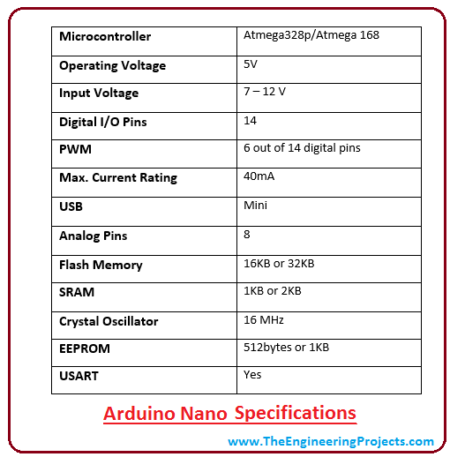](https://www.theengineeringprojects.com/wp-content/uploads/2018/06/introduction-to-arduino-nano-2-2.png)

1. SIM800L GSM/GPRS module

At the heart of the module is a SIM800L GSM cellular chip from SimCom. The operating voltage of the chip is from 3.4V to 4.4V, which makes it an ideal candidate for direct LiPo battery supply. This makes it a good choice for embedding into projects without a lot of space. All the necessary data pins of SIM800L GSM chip are broken out to a 0.1″ pitch headers. This includes pins required for communication with a microcontroller over UART. The module supports baud rate from 1200bps to 115200bps with Auto-Baud detection. The module needs an external antenna to connect to a network. The module usually comes with a Helical Antenna and solders directly to NET pin on PCB. The board also has a U.FL connector facility in case you want to keep the antenna away from the board There’s a SIM socket on the back! Any activated, 2G micro SIM card would work perfectly. Correct direction for inserting SIM card is normally engraved on the surface of the SIM socket.

This module measures only 1 inch² but packs a surprising amount of features into its little frame. Some of them are listed below:

* Supports Quad-band: GSM850, EGSM900, DCS1800 and PCS1900
* Connect onto any global GSM network with any 2G SIM
* Make and receive voice calls using an external 8Ω speaker & electret microphone
* Send and receive SMS messages
* Send and receive GPRS data (TCP/IP, HTTP, etc.)
* Scan and receive FM radio broadcasts
* Transmit Power:
  + Class 4 (2W) for GSM850
  + Class 1 (1W) for DCS1800
* Serial-based AT Command Set
* FL connectors for cell antennae
* Accepts Micro SIM Card

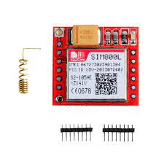

Fig 3.1 SIM800L GSM

1. Neo6M (GPS BOARD)

It is a GPS board used to connect to satellite and used to give altitude and longitude without connecting to internet. The NEO-6 module series is a family of stand-alone GPS receivers featuring the high performance u-blox 6 positioning engine. These flexible and cost effective receivers offer numerous connectivity options in a miniature 16 x 12.2 x 2.4 mm package. Their compact architecture and power and memory options make NEO-6 modules ideal for battery operated mobile devices with very strict cost and space constraints. The 50-channel u-blox 6 positioning engine boasts a Time-To-First-Fix (TTFF) of under 1 second. The dedicated acquisition engine, with 2 million correlators, is capable of massive parallel time/frequency space searches, enabling it to find satellites instantly. Innovative design and technology suppresses jamming sources and mitigates multipath effects, giving NEO-6 GPS receivers excellent navigation performance even in the most challenging environments.

Block diagram for Neo6m:

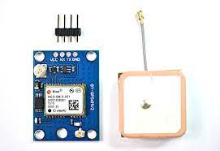

Fig 3.2 GPS Board

GPS receivers are Electrostatic Sensitive Devices (ESD) and require special precautions when handling. For more information see chapter 6.4. Stressing the device beyond the “Absolute Maximum Ratings” may cause permanent damage. These are stress ratings only. The product is not protected against overvoltage or reversed voltages. If necessary, voltage spikes exceeding the power supply voltage specification, given in table above, must be limited to values within the specified boundaries by using appropriate protection diodes.

3.3.3 Software Interfaces

Arduino IDE:

The open-source Arduino Software (IDE) makes it easy to write code and upload it to the board. This software can be used with any Arduino board. To program Arduino from a Chromebook, you can use the Arduino Web Editor on Arduino Cloud. The desktop version of the IDE is not available on Chrome OS. The new major release of the Arduino IDE is faster and even more powerful! In addition to a more modern editor and a more responsive interface it features autocompletion, code navigation, and even a live debugger.

3.3.4 Communication Interfaces

GSM/GPRS:

GPS receivers are Electrostatic Sensitive Devices (ESD) and require special precautions when handling. Stressing the device beyond the “Absolute Maximum Ratings” may cause permanent damage. These are stress ratings only. The product is not protected against overvoltage or reversed voltages. If necessary, voltage spikes exceeding the power supply voltage specification, given in table above, must be limited to values within the specified boundaries by using appropriate protection diodes.

**3.4 Nonfunctional Requirements**

3.4.1 Performance Requirements

Microcontroller- This system needs immediate action and process. That's why, arduino Nano should be used. Using a microcontroller instead of a microprocessor makes space saving as microprocessor makes space saving as microprocessor needs external devices to store data.

Cloud Server-This system needs a fast cloud server which will stay up and running 24/7.

3.4.2 Safety Requirements

The problem which this system solves is a very delicate responsibility. That is why the system will not only send data over cloud but also traditional SMS, so that victims PDU will stay informed with the last valid location

3.4.3 Security Requirements

System is highly vulnerable that it can be easily put down. Making several changes in configuring the cloud will solve all their problems.

DDOS Attack- in DDOS Attack, attacker creates virtual systems and makes then attack a server. Basically, attacker sends request to the server millions of times, which makes server go down.

Solution to DDOS Attack- Inbuilt solution by Blynk This system also sends data to the server. In order to send live location to the server, system needs to send data per second, which can be seen as DDOS Attack by the server.  If this happens, server will cut down connection with the client i.e. our device.

Executed Solution- System doesn’t send location data to Blynk Server. Instead, the server asks the system to send live location every 2 secs. In this way, every unasked data will be ignored automatically. On the top of this, system will also get to know if victims PDU are monitoring location or not.

**3.5 System Requirements**

* + 1. Database Requirements

Blynk: real time databases.

3.5.2 Software Requirements (Platform Choice)

Arduino IDE

3.5.3 Hardware Requirements

A) Arduino Nano

B) Neo6M (GPS BOARD)

C) SIM800L GSM/GPRS module

**3.6 Analysis Models: Agile Model**

The meaning of Agile is swift or versatile."Agile process model" refers to a software development approach based on iterative development. Agile methods break tasks into smaller iterations, or parts do not directly involve long term planning. The project scope and requirements are laid down at the beginning of the development process. Plans regarding the number of iterations, the duration and the scope of each iteration are clearly defined in advance. Each iteration is considered as a short time "frame" in the agile process model, which typically lasts from one to four weeks. The division of the entire project into smaller parts helps to minimize the project risk and to reduce the overall project delivery time requirements. Each iteration involves a team working through a full software development life cycle including planning, requirements analysis, design, coding, and testing before a working product is demonstrated to the client.

Following are the phases in the agile model are as follows:

* Requirements gathering
* Design the requirements
* Construction/ iteration
* Testing/ Quality assurance
* Deployment
* Feedback

**CHAPTER 4**

**SYSTEM DESIGN**

**4.1 System Architecture**

Live location sent

BLYNK CLOUD

LONGITUDE

ALTITUDE

GOOGLE MAP

GPS TRACKER

SAFE BTN

PANIC BUTTON

ARDUINO NANO

GSM

Microcontroller

(Phone will get SMS call and live location from blynk cloud)

Fig 4.1 System architecture

**4.2 System Overview**

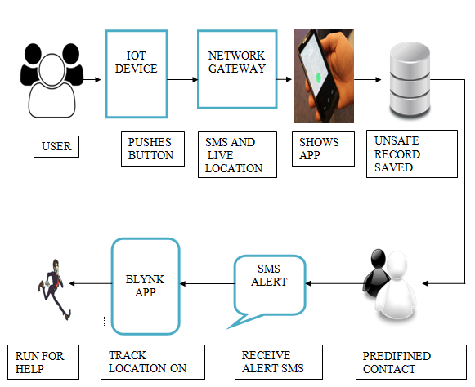

Fig 4.2 System Overview

**4.3 Data Flow Diagrams**

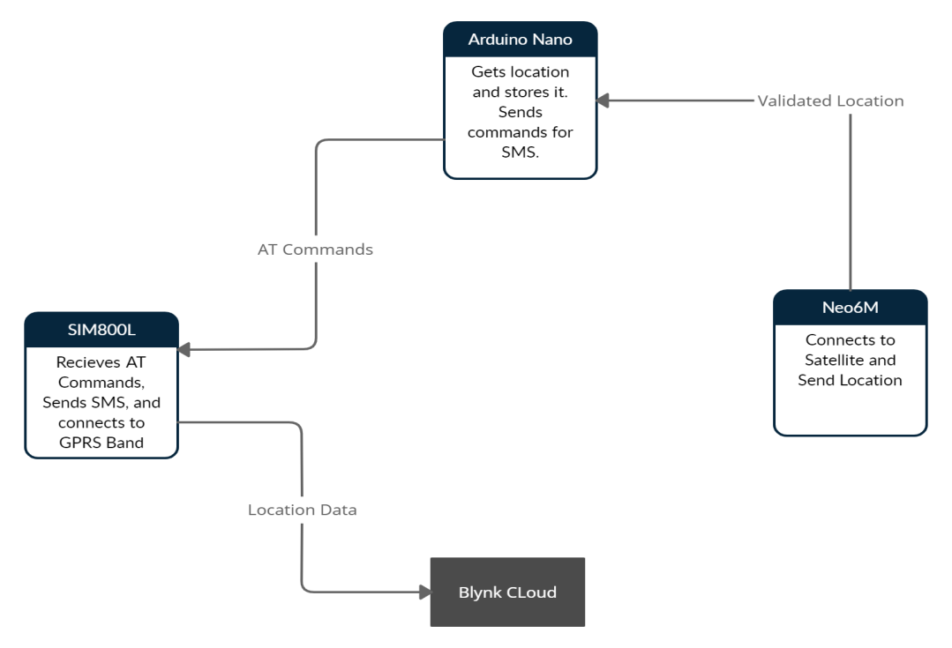

Fig 4.3 DFD level 0

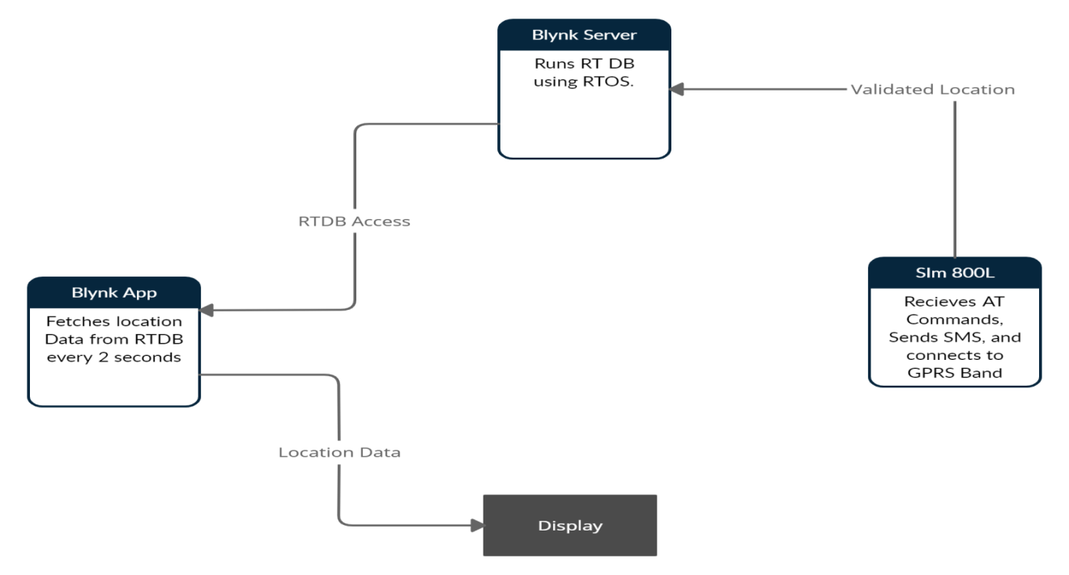

Fig 4.4 DFD level 1

**4.4 Class Diagram**

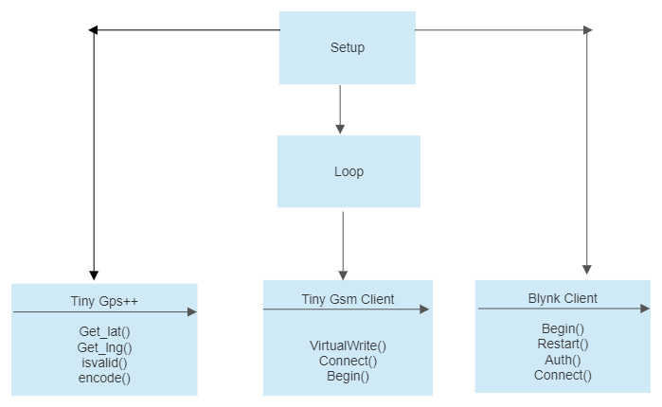

Fig 4.5 Class Diagram

**4.5 Circuit Diagrams**

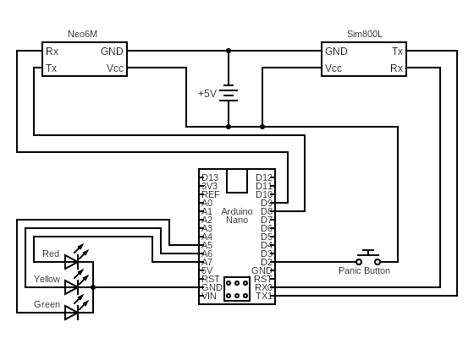

Fig 4.6 Circuit Diagram

**4.6 Deployment Diagram**

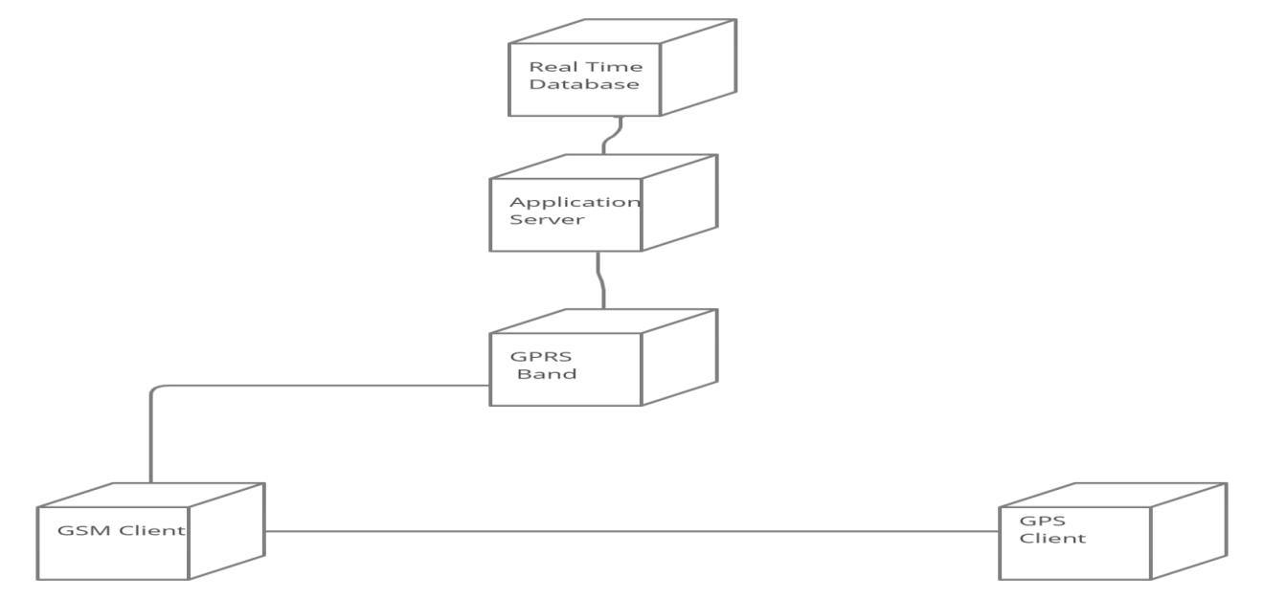

Fig 4.7 Deployment Diagram

**4.7 Use-Case Diagrams**

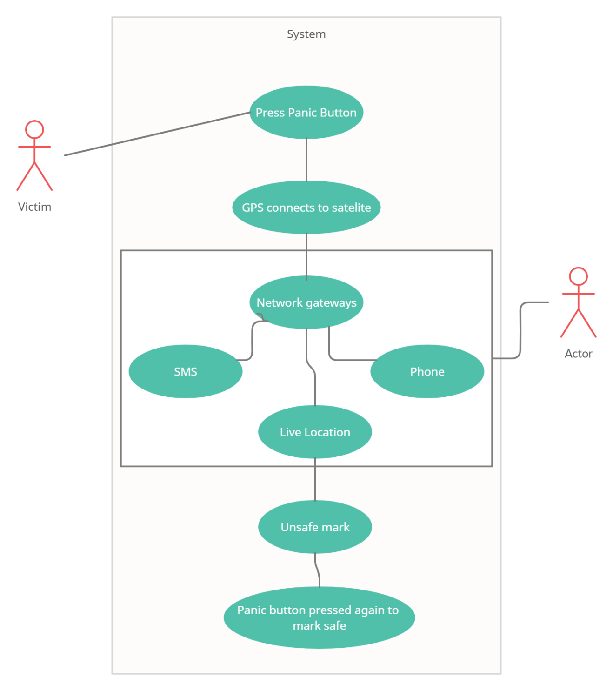

Fig 4.8 Use Case Diagram

**4.8 Sequence Diagram**

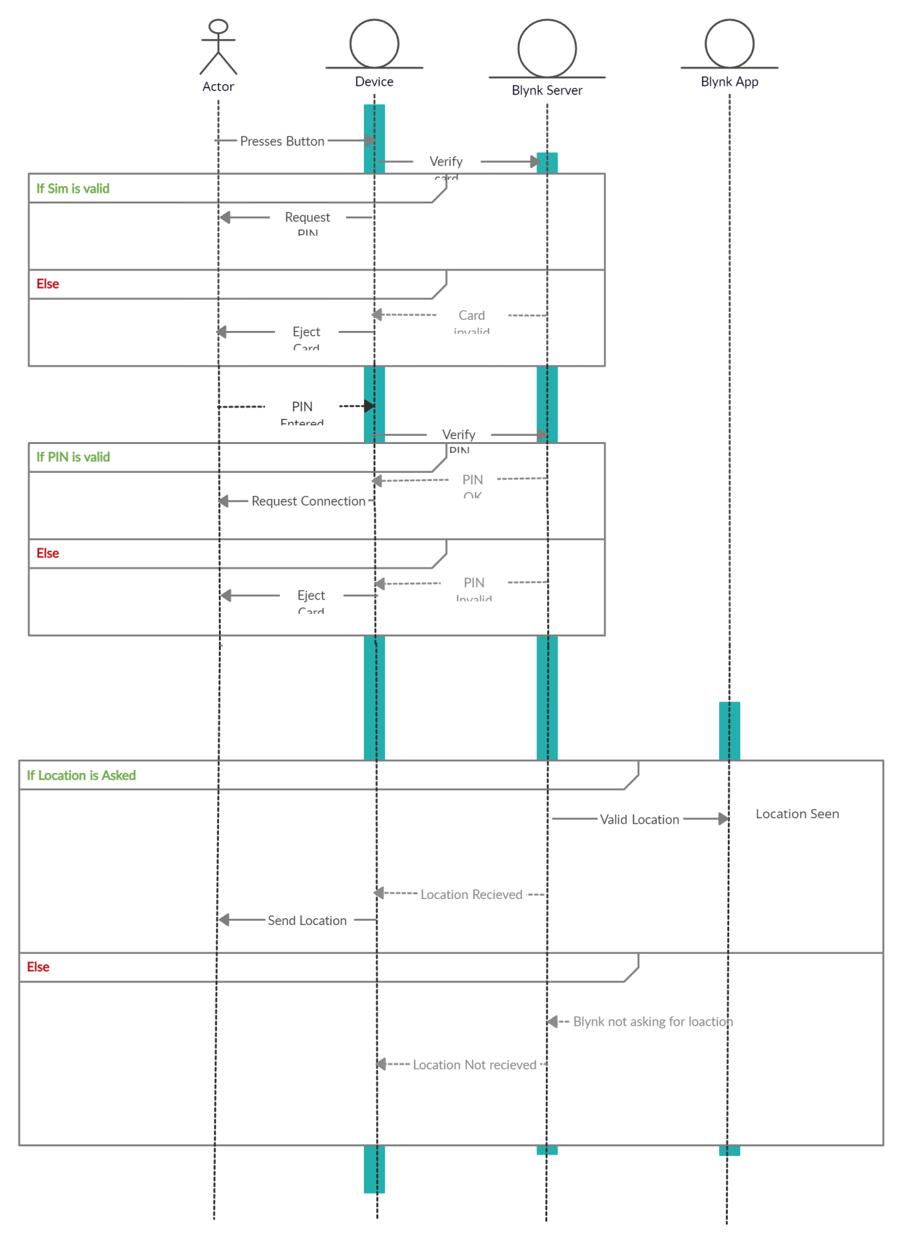

Fig 4.9 Sequence Diagram

**4.9 State Machine Diagram**

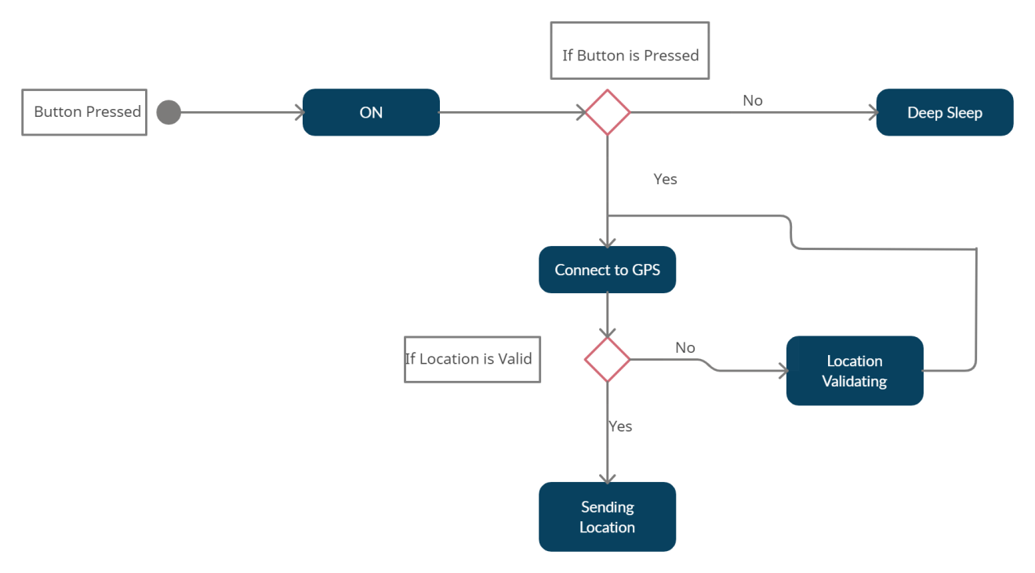

Fig 4.10 State machine Diagram

**CHAPTER 5**

**PROJECT PLAN**

**5.1 Project Estimate**

5.1.1 Reconciled Estimates

Table 5.1 Cost Estimation

|  |  |
| --- | --- |
| **Component** | **Price** |
| Arduino  SIM 800L  Jumper wires, LED, Resistors, Connectors  Neo 6m  **Total** | 400  250  200  600  **1450 Rs** |

**5.2 Risk Management**

Risk Management is the system of identifying addressing and eliminating these problems before they can damage the project. We need to differentiate risks, as potential issues, from the current problems of the project. Different methods are required to address these two kinds of issues.

5.2.1 Risk Identification

Risk identification is the process of determining risks that could potentially prevent the program, enterprise, or investment from achieving its objectives. It includes documenting and communicating the concern. There are five core steps within the risk identification and management process These steps include risk identification, risk analysis, risk evaluation, risk treatment, and risk monitoring.

..

5.2.2 Risk Analysis

Risk analysis in software testing is an approach to software testing where software risk is analyzed and measured. Software risk is measured during testing by using code analyzers that can assess the code for both risks within the code itself and between units that must interact inside the application. Implementing risk analysis in software testing typically requires a detailed evaluation of the source code to identify how it interacts with other components of a complete application. This evaluation looks at the various code components and maps how the code interacts. With this map, transactions can be identified and evaluated. Architectural and structural rules can be applied to the map to understand where software flaws lie and which ones are the most important given the transactions flowing through the application

5.2.3 Overview of Risk Mitigation, Monitoring, Management

Table 5.1 Risk Management

|  |  |  |  |
| --- | --- | --- | --- |
| **Risk** | **Likelihood** | **Impact** | **Mitigation Strategy** |
| Microcontroller stops running. | Low | High | Blynk Server will have most recent location stored in RTDB |
| Device Charge gets low. | Medium | Low | Device goes into deep sleep when Panic Button is not pressed. |
| Device gets lost. | Low | Medium | Blynk Server will have most recent location stored in RTDB |
| No coverage to network | Low | High | To check and confirm if the Sim is working fine and is able to find network |
| Server goes down | Low | Low | If device is not getting asked for location from cloud server, it send SMS with current location every 5 Minutes until server is up and running |
| Server receives DDoS Attack | High | Low | Cloud Server will ignore unasked data. Server itself asks for location every 2 seconds. |

**5.3 Project Schedule**

5.3.1 Project Task Set

Code of Home Emergency system using GSM technology is referred from following options.

1. Finding Project Topic
2. Finding Existing System and disadvantages
3. Implementing Proposed System
4. Collecting information
5. Dynamic programming
6. Testing of Project

5.3.2 Task Network

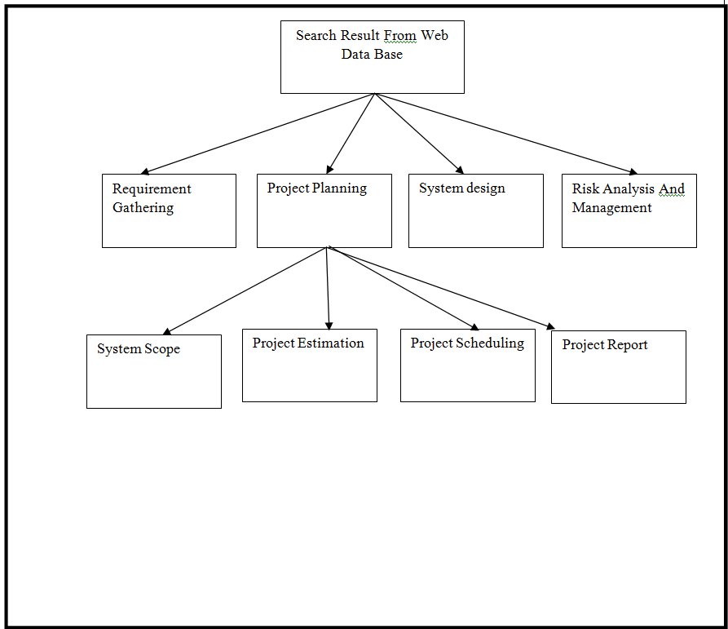

Fig 5.1 project Breakdown Structure

5.3.3 Timeline Chart

When you have a detailed list code safety detector system using GSM technology of all the tasks that you must achieve to complete the project then you can begin to estimate how long each will take. Make sure that you also allow time for project management administration, detailed project, liaison with outside bodies’ resources and authorities, meetings, quality assurance developing supporting documentation or procedures necessary, and training.

Table 5.2 schedule plan

|  |  |
| --- | --- |
| **Week** | **Activities to be done** |
| Week 1 | Searching information to select the topic |
| Week 2 | Selection of topic |
| Week 3 | Communication with guide |
| Week 4 | Requirement gathering |
| Week 5 | Sorting of selective requirements |
| Week 6 | Planning of estimation and scheduling and tracking, Project PPT and Survey Paper |
| Week 7 | Published Survey Paper |
| Week 8 | Modeling, Analysis and designing |
| Week 9 | Construction startup |
| Week 10 | Coding |
| Week 11 | Preparing Implementation Paper |
| Week 12 | Risk management |
| Week 13 | Testing |
| Week 14 | Final testing, Published Implementation Paper |
| Week 15 | Submission of project |

**5.4 Team Organization**

5.4.1 Team structure

It is very important that team work should be managed accurately and each member should be allotted with specific task and he/she should carry the respective responsibility sincerely under the guidance of mentor and proper collaboration and communication.

Team Structure is as Follow

Project guide:

Prof. Swati Gaikwad

NAME: Sheetal

**Role**: Component Gathering, Working Status, Survey paper, ImplementationPaper, Report

NAME: Shriram

**Role:**

Requirement Gathering Coding, Report

NAME: Aniket

**Role**: Architecture Design, Quality Check, Preparrng Survey Paper and Implementation Paper, Report

Fig 5.2 Team structure

**CHAPTER 6**

**PROJECT IMPLEMENTATION**

* 1. **Overview of Project Modules**

Module 1: Integrating GPS with Arduino Nano

Neo6m is cheap GPS module which gives latitude and longitude in Raw form. Neo6m has an antenna which gets connected to satellite. Once connected, it starts sending location through Serial Communication. Then system checks if location is valid or not, if its valid, it gets stored

while (Location. available() > 0)

{

if (gps.encode(Location.read()))

{

if(gps.location.isValid())

{

Serial.println("Valid Location");

sendData();

}

else

{

Serial.println("INVALID LOCATION");

}

}

}

Module 2: Sending SMS and call using Arduino Nano and SIM 800L

Module 2: Sending SMS using Arduino Nano and Sim800L

SMS is sent on GSM band. GSM band is used for sending SMS and Phone calls which are on highest priority. To send SMS or Phone calls, AT commands are used. AT stands for Attention. To operate SIm800L, arduino Nano sends AT commands inorder to send and receive data on GSM Band

Sim.println("AT"); //Attention

delay(500);

Sim.println("AT+CMGF=1"); // GSM module turned into Text Mode

delay(500);

Sim.println("AT+CMGS=\"+919764564684\"\r");// SMS sending AT command for Gsm Module

delay(500);

Sim.print("Emergency, Check Blynk");

delay(500);

Sim.write(26);

Module 3: Connecting to blynk cloud using Arduino Nano and SIM 800L

GPRS band is used to access 2G internet. Most of the modules available in market are 2G modules because its standard and easy to access. System will connect to Blynk using Blynk’s own Client API

charauth[] = "bKpkX65v9FHhQFEg73eaW6GnOqIhkfzP"; // Hash Code of Server Address

charapn[] = "airtelgprs.com"; // Application Private Network

char user[] = "";

char pass[] = "";

TinyGsmmodem(Sim);

delay(10000);

Yellow();

Serial.println("Intitializing Modem..");

modem.restart();

Serial.println("Restarted");

Blynk.begin(auth, modem, apn, user, pass);

Module 4: Integrating 3 modules together and tuning the system.

Finally after Integrating GPS with Arduino Nano , Sending SMS using Arduino Nano and Sim800L and Connecting to Blynk cloud using Arduino Nano and SIM 800L , whole module is tuned together . At the end device waits for server to ask for location data. Once server asks for the data, BLYNK_READ() gets executed.

BLYNK_READ(V2)

{

getGPS();

SendMessage();

SendData();

}

void loop() {

// put your main code here, to run repeatedly:

Blynk.run();

}

* 1. **Tools and Technologies Used**

Arduino IDE:

The Arduino Integrated Development Environment (IDE) is a cross-platform application (for Windows, macOS, Linux) that is written in functions from C and C++. It is used to write and upload programs to Arduino compatible boards, but also, with the help of third-party cores, other vendor development boards.

GSM:

GSM is combination of TDMA (Time Division Multiple Access), FDMA (Frequency Division Multiple Access) and Frequency hopping. Initially, GSM use two frequency bands of 25 MHz width: 890 to 915 MHz frequency band for up-link and 935 to 960 MHz frequency for down-link. Later on, two 75 MHz band were added

GPRS:

General Packet Radio Service (GPRS) is a packet oriented mobile data standard on the 2G and 3G cellular communication network's global system for mobile communications (GSM). It provides moderate-speed data transfer, by using unused time division multiple access (TDMA) channels in, for example, the GSM system

GPS:

GPS stands for Global Positioning System. GPS satellites carry atomic clocks that provide extremely accurate time. The time information is placed in the codes broadcast by the satellite so that a receiver can continuously determine the time the signal was broadcast.

* 1. **Algorithm Details**

6.3.1 Algorithm

**Step 1**: GPS gets connected to satellite.

**Step 2:** Microcontroller gets raw location data from GPS module i.e. Neo6m.

**Step 3:** This raw data gets converted into readable data.

**Step 4:** Latitude and longitude gets validated.

**Step 5**: Sim card gets registered to APN network.

**Step 6**: Call and SMS is sent to three predefined users.

**Step 7**: Device waits until server asks for the location data.

**Step 8**: Most recent valid location is sent to the server after it asks for it.

**Step 9**: Server sends acknowledgement to device.

**CHAPTER 7**

**SOFTWARE TESTING**

**7.1 Type of Testing**

7.1.1 Unit Testing

Unit testing involves the test cases that validate that internal logic in functioning properly and that programming input module produced validate output.

7.1.2 Integration Testing

Integration test is designed to integrate software component to if then actually run as one program. Testing is event driver and is more enter with the basic outcome of screen or fields. Integration test demonstrate the although the component where individually satisfaction as shown by successful.

7.1.3 White Box Testing

White box testing is a testing in which the software tested had knowledge of the inner working structure and language of the software. Or atleast its purpose it use to test area of that can not be reached from a black box level.

7.1.4 Black Box Testing

Black box testing is a testing without any knowledge inner working structure or language of module being tested. Black box test as most order kind of test, mostly written form a definitive source of document. Such as specification or requirement document. It is a testing which is software under the treated.

**7.2 Test Cases and Test Results**

Table 7.1 Test cases

|  |  |  |  |  |  |
| --- | --- | --- | --- | --- | --- |
| Sr.no | Purpose | Steps | Expected results | Actual result | Status |
| 1 | To check Correct number is used to send SMS | Press the panic button. | Numbers Should get SMS | Numbers  Are valid and SMS commands are working correctly. | Pass |
| 2 | To check GPS sensor | Check Serial port by connecting Neo 6m | Raw location should be received on serial port. | Location is received on serial port | Pass |
| 3 | To check if location is valid or not | Compare serial data location and GPS data on phone | Both locations should be Same | 90% of times Location is same(valid) | Pass |
| 4 | To check SIM is connected to network. | Keep sim card in GSM Module | GSM Network light should get ON. | GSM network light got on. | Pass |
| 5 | To check if sim card is working | Call to the sim card. | LED should get turned ON. | LED got turned ON. | Pass |
| 6 | To check if Arduino is working. | Connect module to PC. | Serial Monitor should be showed up. | Serial Monitor showed. | Pass |
| 7 | To check if Panic button is working correctly | Press the panic Button | SMS should get within 2 seconds and location should be received on Blynk server app | SMS got as soon as panic button was pressed along with location on app. | Pass |
| 8 | To check if server ask for the data to device | Press the panic button and run the server | Server should ask for data every two seconds | Server asked for the data and data was being sent. | Pass |

**CHAPTER 8**

**RESULTS**

**8.1 Outcomes**

* When the panic button was pressed, red LED is lighted on device.
* SMS was received on three different numbers and Yellow LED is lighted on device
* Live location has been received on blynk app and Green LED was turned on.

**8.2 Screen Shot**

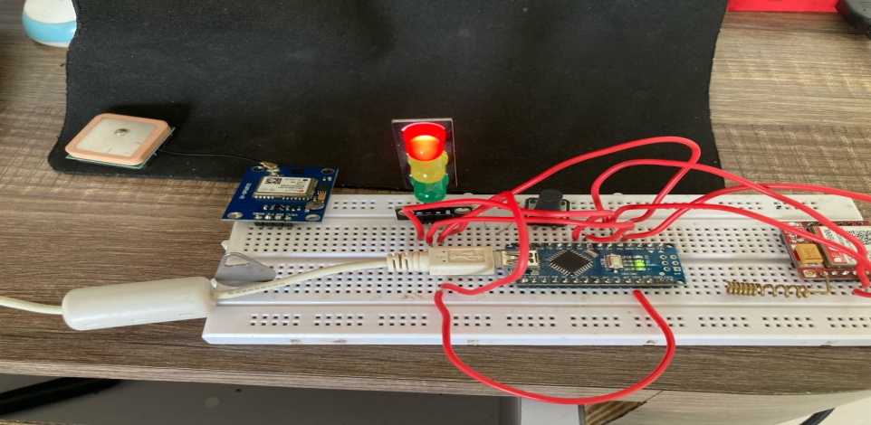

Fig 8.1 Panic Button Pressed

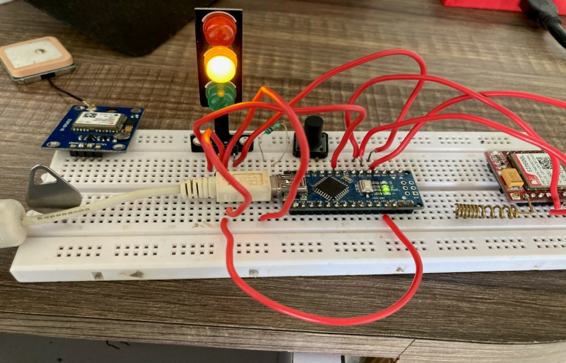

Fig 8.2 Moderately Safe Sign

(SMS, Phone and Live Location has been sent)

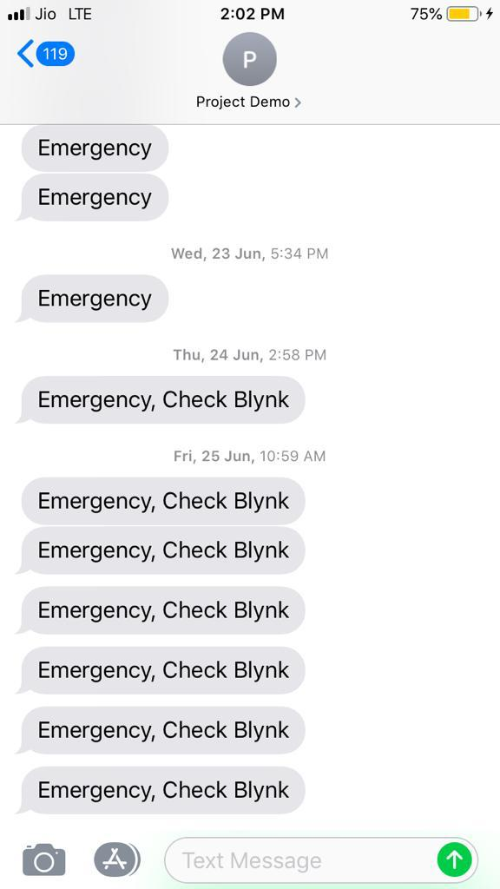

Fig 8.3 Emergency Blynk 1



Fig 8.4 Emergency Blynk 2

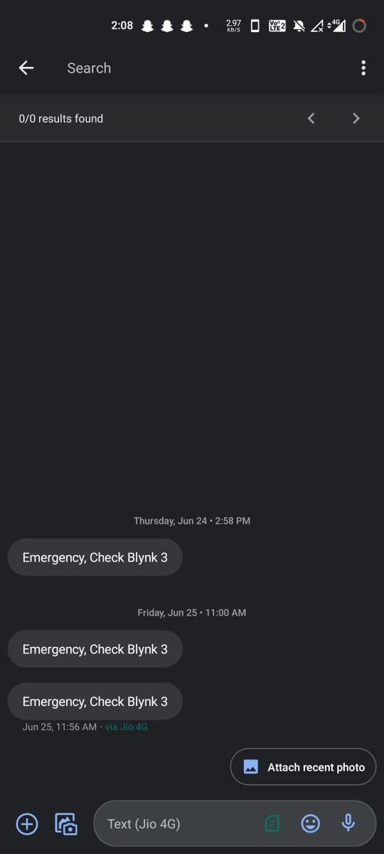

Fig 8.5 Emergency Blynk 3

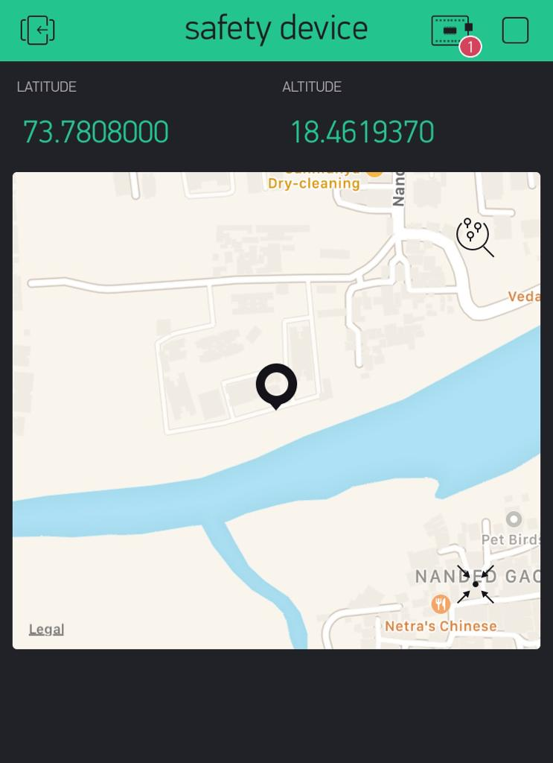

Fig 8.6 Location viewed on phone

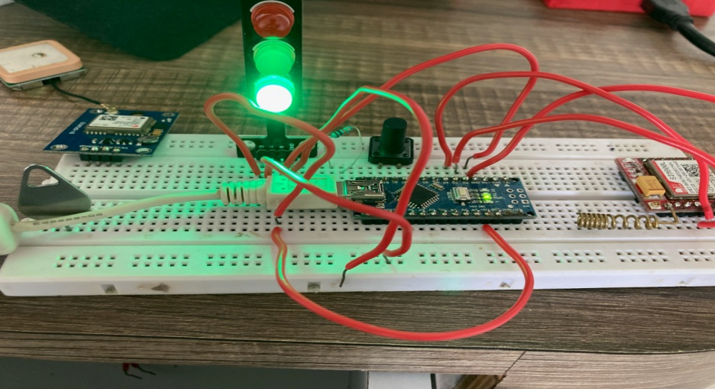

Fig 8.7 Safe Sign

(Location is being seen by PDU)

**CHAPTER 9**

**CONCLUSIONS**

**9.1 Conclusions**

Women in our country are unsafe everywhere. Public place safety is the need of the hour because the cases of harassment are increasing day by day. There are many reasons why women chose to keep silent when they come across any sort of harassment. The main motto behind initiating this application is to empower women and encourage them to claim their rights when injustice takes place. This application will help them express their views and make it go viral to ensure create a safe environment for others. Through this app women themselves will become self sufficient to help each other when it comes to ensuring their safety at public place. Though this is a baby step but can turn out to be a big revolutionary step over a period of time.

**9.2 Future Work**

Storing and training the data using Machine Learning Algorithm can give notification even before she enters area. We may add a feature of emergency helpline numbers such as nearby police stations, Women help groups, nearby NGOs etc. This app can be customized and used at a workplace to address the workplace harassment. We can also link police dept through this app and the notification can be sent through this app to nearby on duty police and they can be at the crime scene within minutes. The translation of the content can be done in Local languages.  An offline survey can be conducted with the help of this application and testimonials of real live witnesses can be added for others to refer as a strong evidence.

**9.3 Applications**

* This device can be used in any emergency situation by any person.
* The purpose of a panic alarm is to allow a person under duress to quickly and silently call for help in the event of an emergency. Panic alarms are also called "duress alarms", "hold-up alarms", or "panic buttons". Panic alarms are used when it may be unsafe or uncomfortable to call for help in other ways.
* This device can be used by solo travelers and Children.
* Same proof of concept can be used in cars, so stolen cars can be found easily.

**REFERENCES**

1. **A Women Safety Portable Hidden camera detector and jammer**

S. K, R. Subhashini, S. Gowri and J. S. Vimali, "A Women Safety Portable Hidden camera detector and jammer," *2018 3rd International Conference on Communication and Electronics Systems (ICCES)*, Coimbatore, India, 2018, pp. 1187-1189, doi: 10.1109/CESYS.2018.8724066.

1. **Development of a Wireless Safety System Based on Multiple Radiation Detector for Nuclear Facilities**

M. S. Muktadir, S. Islam and A. R. Alam Chowdhury, "Development of a Wireless Safety System Based on Multiple Radiation Detector for Nuclear Facilities," *2019 International Conference on Robotics,Electrical and Signal Processing Techniques (ICREST)*, Dhaka, Bangladesh, 2019, pp. 539-542, doi: 10.1109/ICREST.2019.8644312.

1. **Millimeter wave safety warning system for in-vehicle signing**

G. Greneker, "Millimeter wave safety warning system for in-vehicle signing," in *IEEE Aerospace and Electronic Systems Magazine*, vol. 13, no. 7, pp. 7-12, July 1998, doi: 10.1109/62.690727.

1. **A new proposal for the analysis of safety instrumented systems**

M. Catelani, L. Ciani and V. Luongo, "A new proposal for the analysis of safety instrumented systems," *2012 IEEE International Instrumentation and Measurement Technology Conference Proceedings*, Graz, Austria, 2012, pp. 1612-1616, doi: 10.1109/I2MTC.2012.6229556.

1. **Structure of Automated Railway Electric Vehicle Safety Control System**

A. Mor-Yaroslavtsev, A. Levchenkov and L. Ribickis, "Structure of Automated Railway Electric Vehicle Safety Control System," ***2010 Second WRI Global Congress on Intelligent Systems***, Wuhan, China, 2010, pp. 39-42, doi: 10.1109/GCIS.2010.201

1. **An embedded system of dedicated and real-time fire detector and locator technology as an interactive response mechanism in fire occurrence**

S. Abaya, E. Cabico, J. Domingo, R. Diaz, H. Kojima and R. Rivera, "An embedded system of dedicated and real-time fire detector and locator technology as an interactive response mechanism in fire occurrences," ***2016 IEEE International Conference on Advances in Electronics, Communication and Computer Technology (ICAECCT)***, Pune, 2016, pp. 407-411, doi: 10.1109/ICAECCT.2016.7942622

1. **Test coverage of the safety instrumented system**

J. Jin, S. Zhao and B. Hu, "Test coverage of the safety instrumented system," *Proceedings of the 30th Chinese Control Conference*, Yantai, China, 2011, pp. 4228-4231.

1. **The detector safety system for LHC experiments**

S. M. Schmeling, B. Flockhart, S. Luders and G. Morpurgo, "The detector safety system for LHC experiments," in *IEEE Transactions on Nuclear Science*, vol. 51, no. 3, pp. 521-525, June 2004, doi: 10.1109/TNS.2004.828631.